**Practical No. 4**

**Excersize:** Refers to what has been seen in class. Using ERDPLUS , design star schema using any ERD except HR or class lecture erd and generate code and execute this on sql live or oracle apex.

**Entity Realtionship Diagram of Student Enrollment System:**  
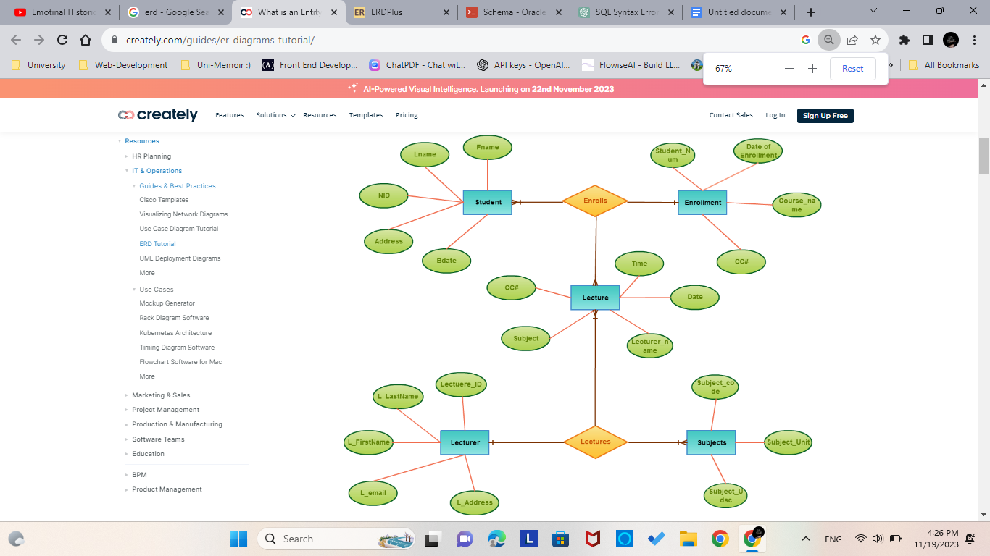

**Star Schema:**  
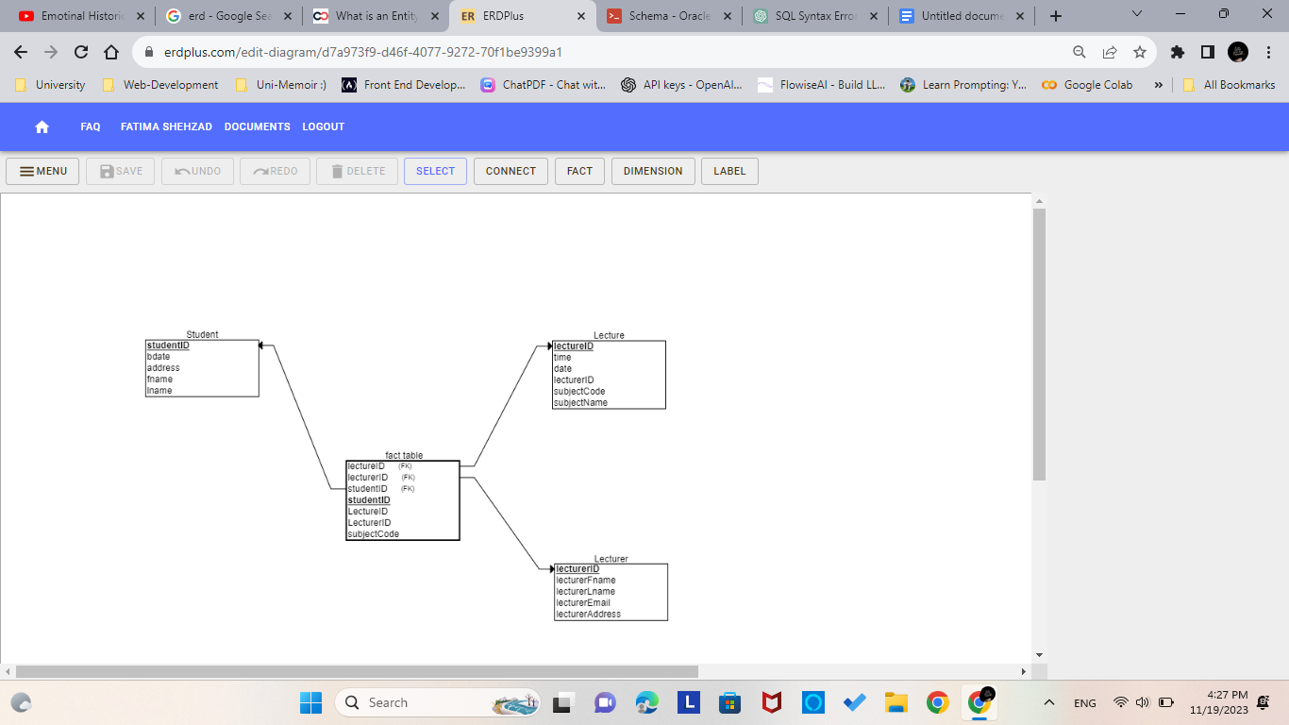

**SQL generated by ERDPlus:**

CREATE TABLE Facttable

(

studentID INT NOT NULL,

LectureID INT NOT NULL,

LecturerID INT NOT NULL,

subjectCode VARCHAR(10) NOT NULL,

PRIMARY KEY (studentID),

FOREIGN KEY (LectureID) REFERENCES Lecture(lectureID),

FOREIGN KEY (LecturerID) REFERENCES Lecturer(lecturerID),

FOREIGN KEY (studentID) REFERENCES Student(studentID)

);

CREATE TABLE Student

(

studentID INT NOT NULL,

bdate VARCHAR(20) NOT NULL,

address VARCHAR(50) NOT NULL,

fname VARCHAR(20) NOT NULL,

lname VARCHAR(20) NOT NULL,

PRIMARY KEY (studentID)

);

CREATE TABLE Lecture

(

"time" VARCHAR(10) NOT NULL,

"date" DATE NOT NULL,

lecturerID INT NOT NULL,

lectureID INT NOT NULL,

subjectCode VARCHAR(10) NOT NULL,

subjectName VARCHAR(50) NOT NULL,

PRIMARY KEY (lectureID)

);

CREATE TABLE Lecturer

(

lecturerID INT NOT NULL,

lecturerFname VARCHAR(20) NOT NULL,

lecturerLname VARCHAR(20) NOT NULL,

lecturerEmail VARCHAR(50) NOT NULL,

lecturerAddress VARCHAR(50) NOT NULL,

PRIMARY KEY (lecturerID)

); **Star Schema generated through the SQL queries by Oracle Live:**

